 

***Practicum of Optoelectronics I***

**Supervised by**

Safoura Nazemroaya

Submitted by

|  |  |
| --- | --- |
| Akshesh A. Chavda | 35391852 |
| Akanchha Choudhary | 35402525 |

Contents

1 Introduction 2

2 Fundamentals 2

2.1 Reflection 2

2.2 Refraction 3

2.3 Diffraction 3

2.4 Snell’s Law 3

2.5 Bragg’s Condition 3

2.6 Distributed Bragg Mirror (DBR) 4

2.7 Fabry Perot filter 5

3 Simulation 6

3.1 Task 1 6

3.2 Task 2 8

3.3 Task 3 10

3.4 Task 4 11

4 Measurements 12

5 Conclusion 16

6 References 17

# Introduction

In the lab training of Optoelectronics Devices I, we have analyzed and simulated the performance of Distributed Bragg Reflector (DBR) and Fabry Perot filter for various materials used in their fabrication with the help of Openfilters Software. After that we have seen the performance of the DBR mirrors and Fabry-Pérot filter, which is fabricated at Institute of Nanostructure Technologies and Analytics (INA) and correlate it with the simulated outcomes. It is done with the help of OOIBase 32 Software.

# Fundamentals

## **Reflection, refraction and diffraction**

Reflection is the change in the direction of the wave at the interface of two different medium such that the wave is returned to the same medium from which it is originated.

Refraction is the phenomena where the direction of the wave passing from one medium to another medium gradually changes.

Diffraction is the phenomena of bending of wave when it encounters an obstacle or a slit during its propagation.

## **Snell’s Law**

Snell’s law is used to describe the relationship between the angle of incidence and refraction when the wave passes through a boundary between two different medium, such as water, glass and air.

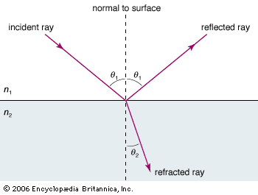

Figure 1 schematic diagram of Snell's Law

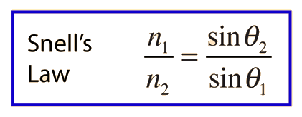

**Where n1 & n2 is the refractive indices of 1st medium(air) and 2nd medium(glass) respectively**

**Theta is the angle with which the ray bends reflect.**

## 

## **Bragg’s Condition**

This law gives the condition for constructive interference. It states that if two beams with same wavelength and phase approaches a crystal, the lower beam travels more distance than the upper beam. If that distance is equals to the integral multiple, then constructive interference will occurs.

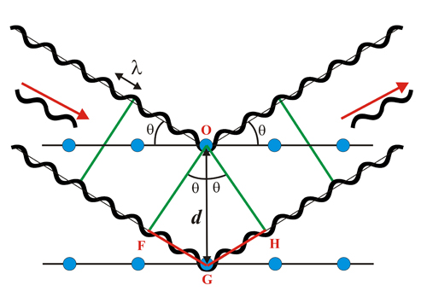

Figure 2 Schematic diagram of Bragg’s Law

**Bragg’s Law: *2d sin θ = n. λ***

***Where d=distance between two waves.***

***n=refractive index of the medium in which wave is travelling.***

***λ is the wavelength of the wave***

## **Distributed Bragg Mirror**

Distributed Bragg Reflector (DBR) is the structure formed by multiple layers of alternating materials having different refractive index. It acts as reflector for all those wavelengths whose quarter wavelength is not equals the optical thickness of the layer. The range of wavelengths which are reflected is called as Stopband, which is shown in the figure.

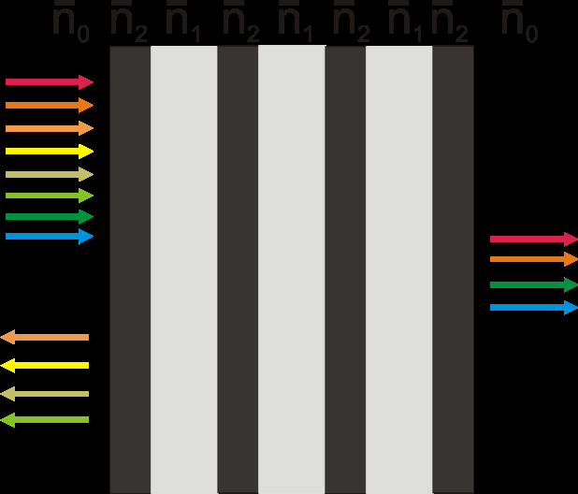 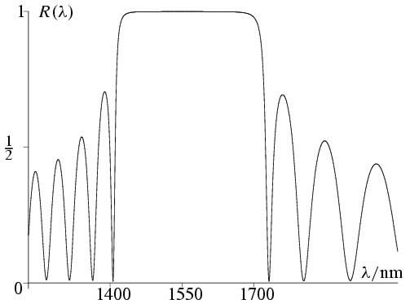

The width of the stopband can be widened by increasing the refractive index difference of mirror layers. Whereas, reflectivity can be increased by increasing number of periods.

Figure 3 structure of a Distributed Bragg Reflector and it’s Reflectance curve

## **Fabry Perot filter**

Fabry-Pérot filter is the Fabry Perot Interferometer having two DBRs instead of ideal mirror. The reflectance curve of this filter shows a dip for certain wavelength which indicates that particular wavelength will get resonated in the cavity and only that wave is transmitted from this filter. So, the cavity distance should be the integral multiple of half a wavelength. It can be controlled by controlling the cavity width.

The efficiency of the filter can be measured by measuring Finesse which is the ratio of the Free spectral range (FSR) and full width half maximum (FWHM).

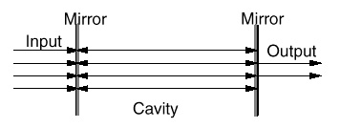

Figure 4 Fabry Perot filter

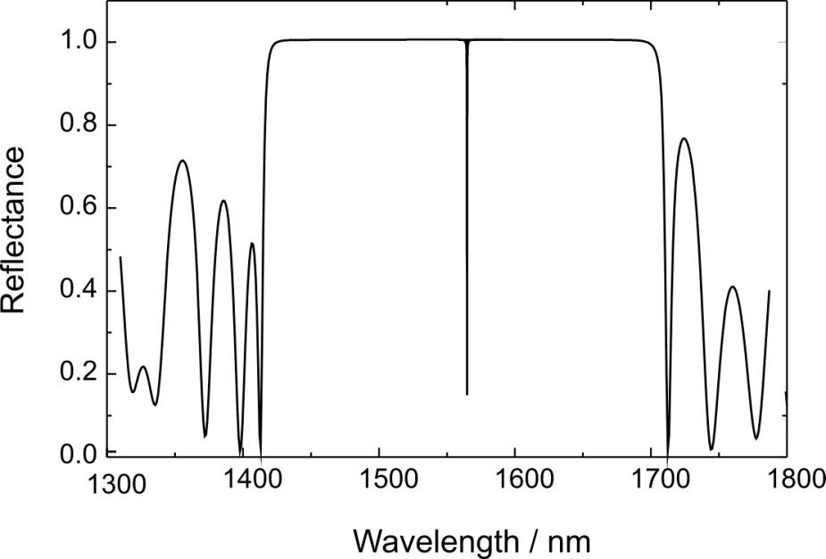

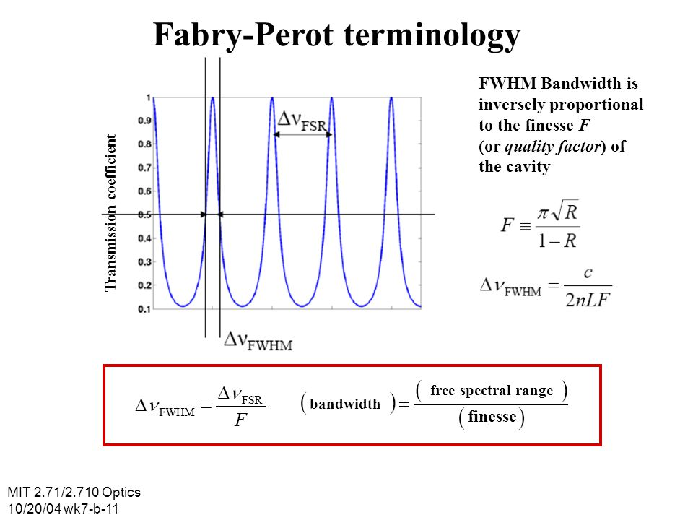

Figure 5 Transmission curve showing Finesse

# Simulation

## Task 1

Initially in this task we have simulated a DBR of 25 layers having alternative layers of SiO2 and Si3N4. Silicon nitride has higher refractive index compared to silicon dioxide. This DBR has a Stopband for 500-600 nm with central wavelength at 550 nm.The reflectance curve of the DBR is obtained as shown in Figure 3.1,

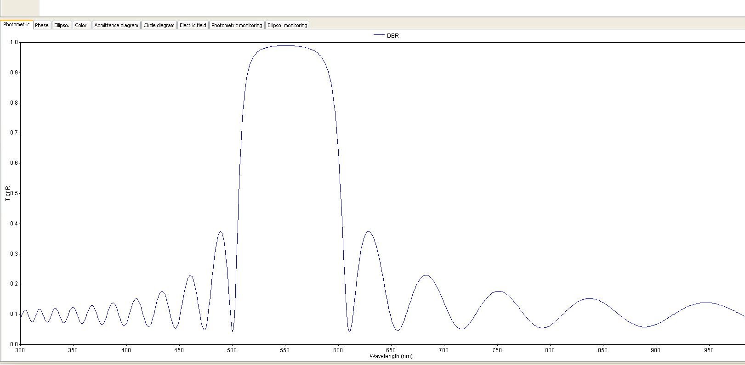

Figure 3.1 Distributed Bragg Reflector

Using this DBR we had constructed three Fabry Perot filter having different cavity width. The cavity material for all FP filter is same i.e. SiO2. The reflectance curves of these FP filters are shown in figure? and it indicates that with the increase in cavity width higher wavelength is resonated in the cavity and is transmitted from the filter.

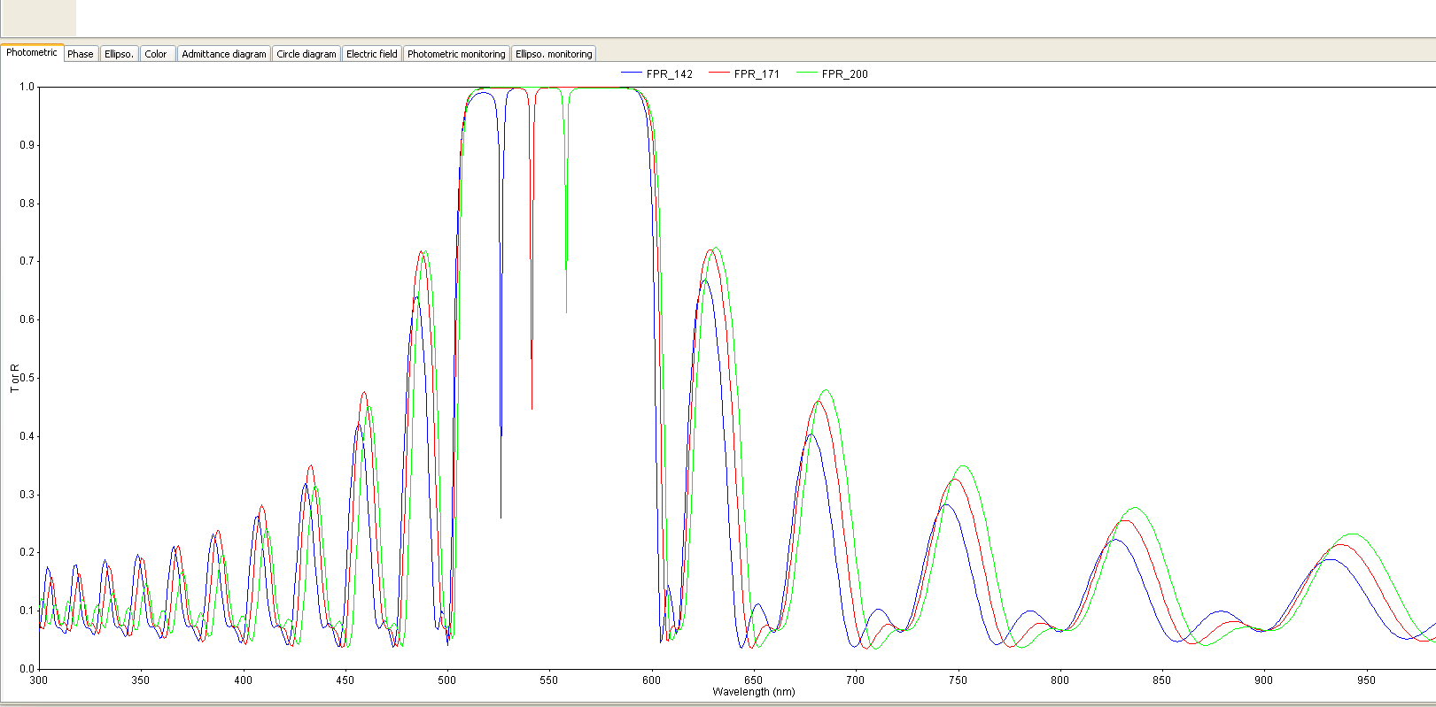

figure3.2 reflectance curves of Fabry Perot filter with variable cavity length

## Task 2

Now in this task we worked on 4 different design of FP filter and found the best one among all. The cavity material used for this task is Ormocomp having refractive index of 1.55.

The four different designs are as follow,

1. (HL)12 C (LH)12
2. (LH)12 C (HL)12
3. L(HL)12 C L(HL)12
4. H(LH)12 C H(LH)12 where, H - high refractive index material

L - Low refractive index material

C - Cavity material

The best design among all is the 4th one and it has the highest reflectivity and sharpest dip compared to other designs. It is clearly visible in the simulation shown below,

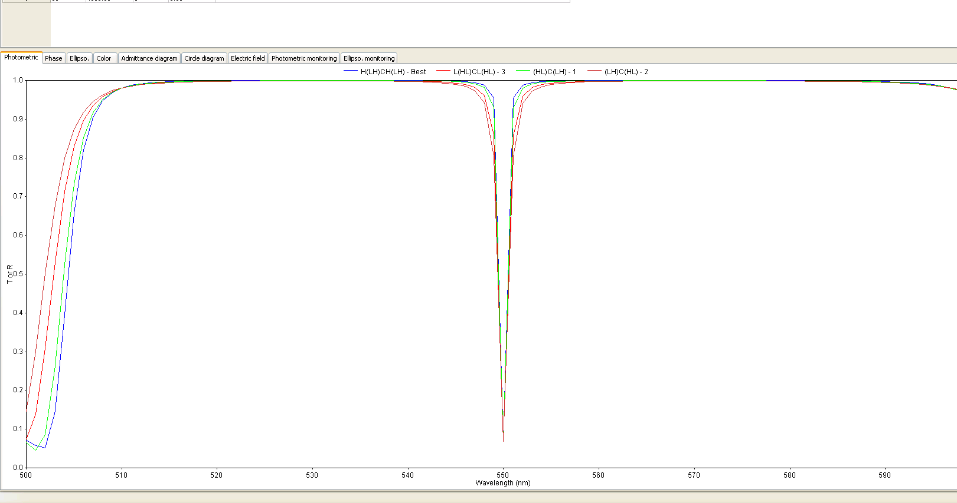

Figure 3.3 reflection cureves of FP filters with different design of DBR

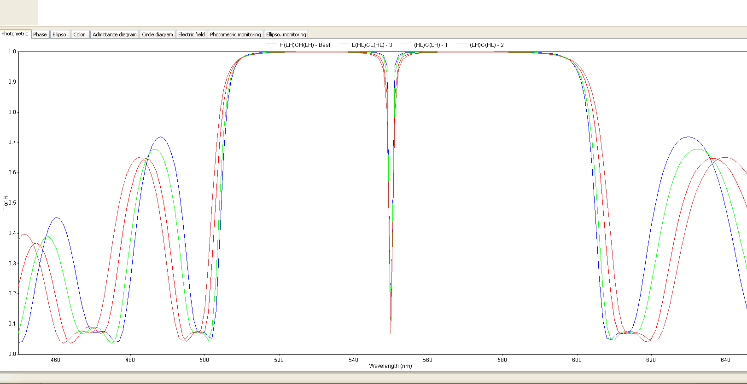

Figure 3.4 Reflectance curves of FP filters with different DBR design

## Task 3

This task was regarding the characteristics analysis of filter influenced by different materials of DBRs. Here the lower refractive index material SiO2 remains fixed for all different DBRs and higher refractive index material are changed. Zirconium dioxide, Silicon nitride and Titanium dioxide are used as higher refractive index materials.

The reflectance curves of all three different DBRs is shown below. It can be clearly analyzed from the simulation (see Figure 3.5) that with the increment in the contrast the width of the Stopband increases.

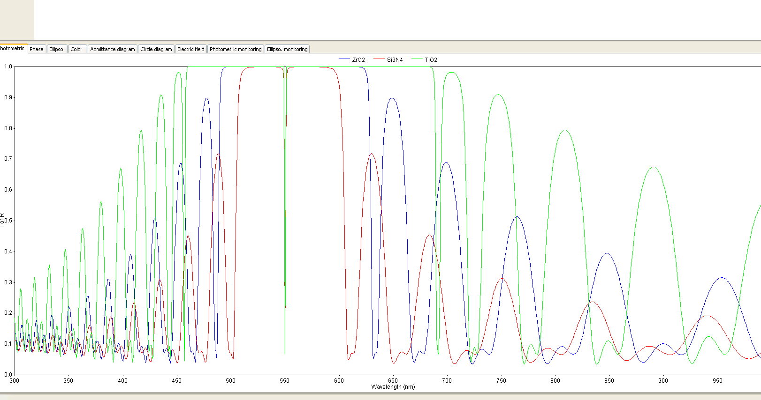

Figure 3.5 reflectance curves of FP filters with different DBR materials

## Task 4

This task was about the impact of different DBRs periods over the characteristic of the filter. Here, the first filter is made from the DBR having period m=3 and the other one is made from the DBR having period m=9.

It can be clearly noticed that the filter having DBR of higher period has very sharp dip as well as very high reflectivity as compared to that of the one having lower number of periods (Figure 3.6).

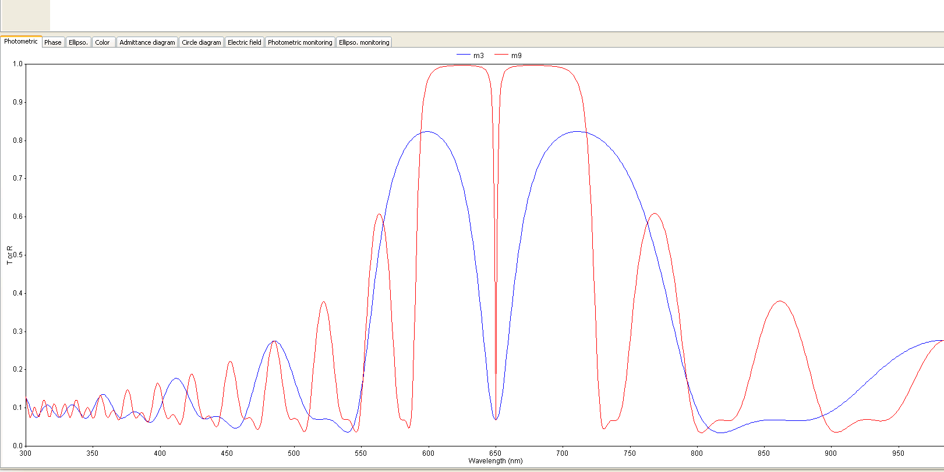

Figure 3.6 reflectance curves of FP filters with different number of DBR periods.

# Measurements

After doing simulation we undertook the experiment of real DBR and Fabry Perot filter fabricated at INA and did the measurements with a microscope spectrometer setup and OOIBase 32 Software.

Figure 4. 1 measured reflectivity of a Distributed Bragg Reflector

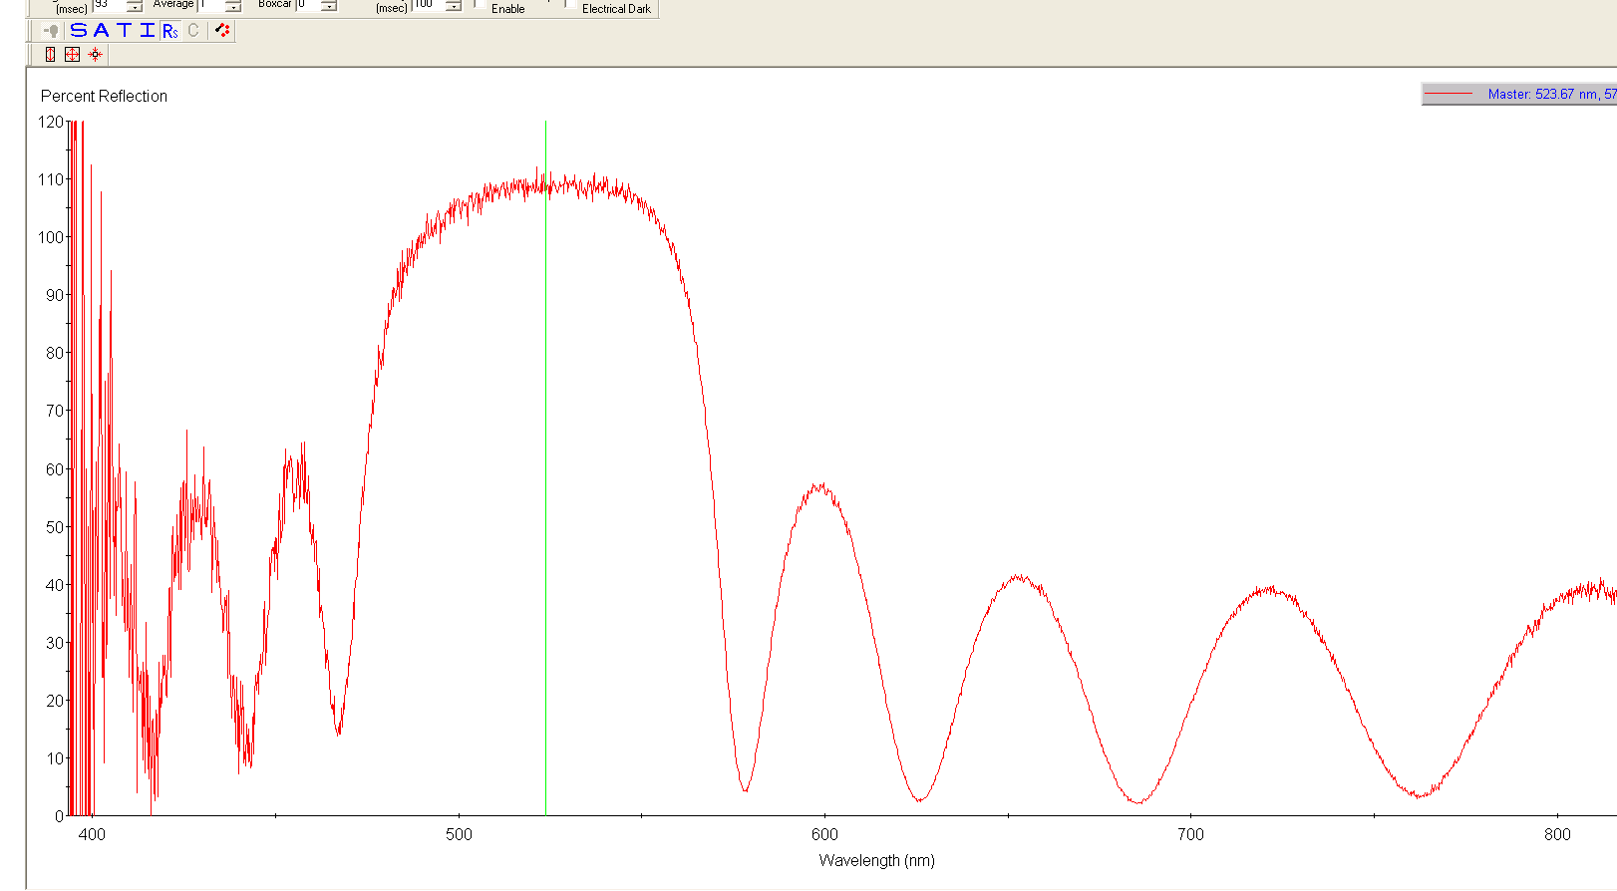The reflectance curve of the real DBR is measured as shown in Figure 4.1. Here we can see that the Stopband is not from 500-600 nm as obtained as simulation. It is due to some error during its fabrication.

After that, we measured the reflectance curve of real Fabry Perot filter having variable cavity width and obtain the dip at various wavelength.

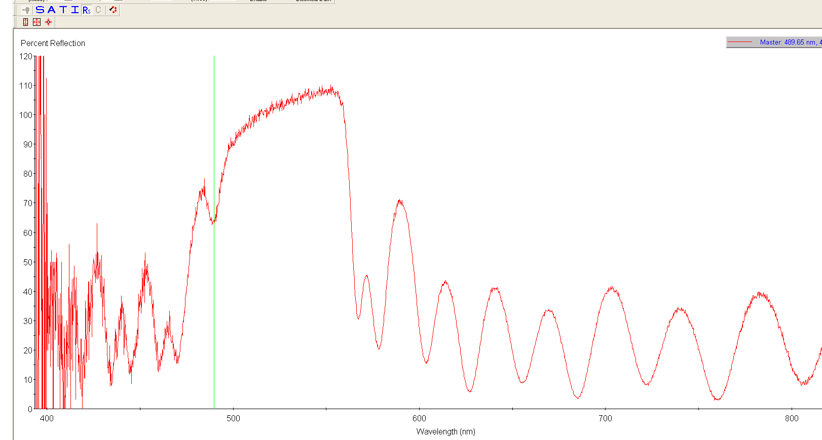

Graph 2 Reflectance curve of Fabry Perot filter with cavity length 142.25nm

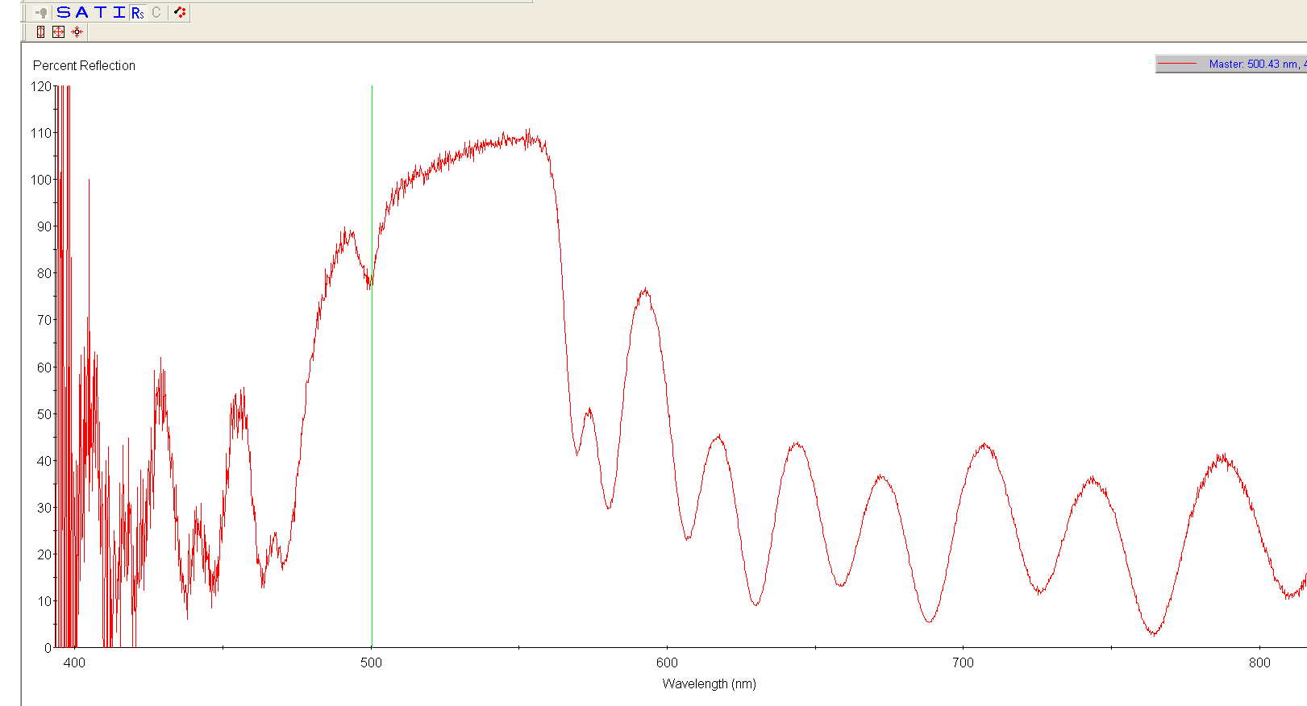

Graph 3 Reflectance curve of Fabry Perot Filter with cavity length 171.48nm

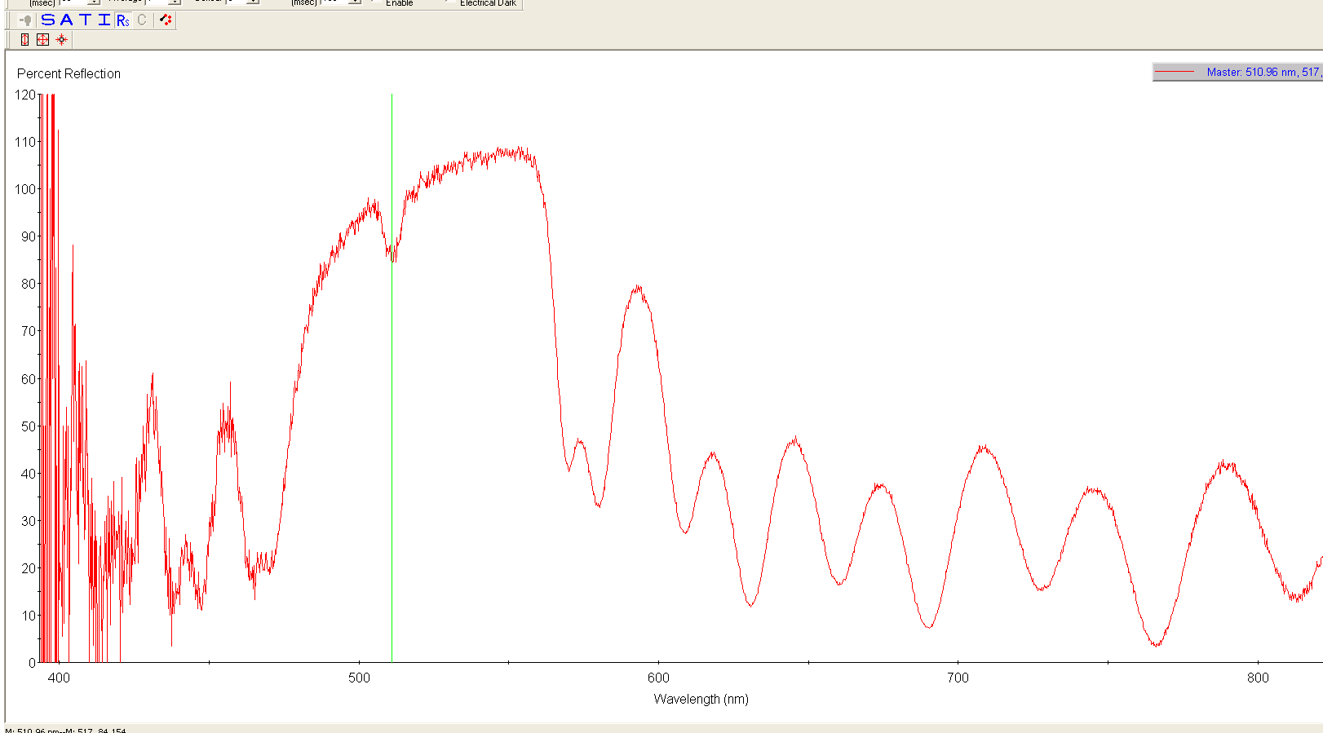

Graph 4 Reflectance curve of Fabry Perot Filter with cavity length 200.71nm

The two measurements shown below is the transmission curve of the Fabry Perot filter having DBR with different periods. The first transmission curve is of the filter having DBR with period m=3 and second curve is filter with period m=9.

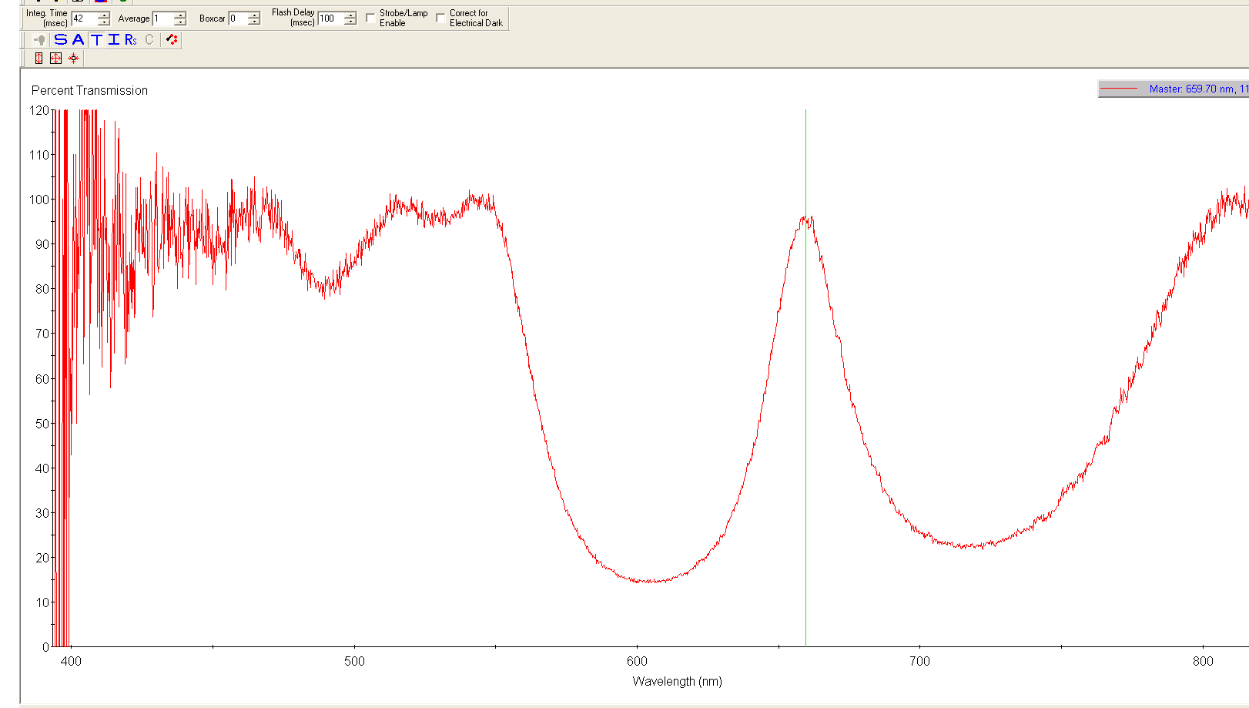

Graph 5 Transmission curve of Fabry Perot Filter using DBR with m=3

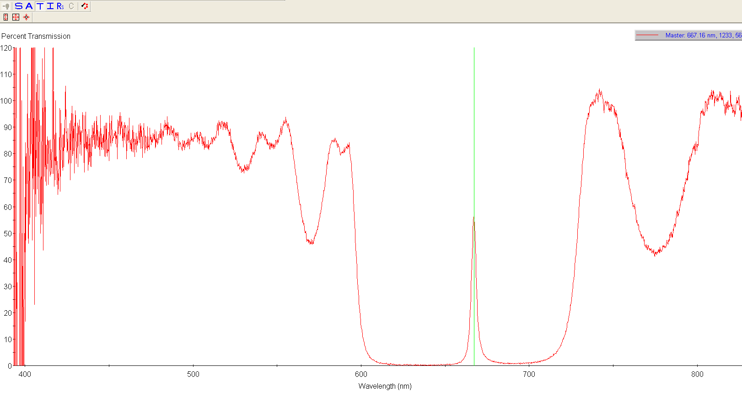

Graph 6 Transmission curve of Fabry Perot Filter using DBR with m=9

# Conclusion

By doing this experiment we see how materials with different refractive index, cavity width and number of periods affects the performance of Distributed Bragg Reflector (DBR) and Fabry Perot filter. We have also acquired the knowledge regarding how to fabricate efficient filter by keeping various factors in mind.

# References

1. <https://kids.britannica.com/students/assembly/view/91336>
2. <http://hyperphysics.phy-astr.gsu.edu/hbase/phyopt/Fermat.html>
3. <http://www.xtal.iqfr.csic.es/Cristalografia/parte_05_5-en.html>
4. Manuscript of Optoelectronic Devices , Prof. Dr. H. Hillmer
5. <http://imedea.uib-csic.es/~salvador/docencia/coms_optiques/addicional/ibm/ch03/03-09.html>
6. <https://slideplayer.com/slide/730230/>